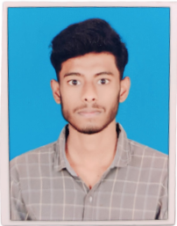

**RESUME**

# Mr BADE SARATH KUMAR

Email ID: badesarathkumar@gmail.com

Mobile: +91-9391902002



To be able to use my analytical & technical skills to reach a challenging position where I can effectively contribute to the development of the organization in which I work.



|  |  |  |  |
| --- | --- | --- | --- |
| **Academic Qualification** | **University\College\School** | **Year of Passing** | **Percentage\CGPA** |
| B.Tech (cyber security) | Godavari institute of Engineering and technology,  Rajamahendravaram. | 2026 | 7.81(upto to 2-2) |
| Intermediate | Sri Chaitanya Jr college,  Vishakapatnam . | 2022 | 87% (870) |
| SSC | ZPHS high school,  Seethapuram. | 2020 | 9.8 |



* C
* Data structures
* Python
* Java



* Team player
* Hard working
* Self confidence
* Good listener
* Positive thinking
* Fast learner



|  |  |  |
| --- | --- | --- |
|  |  |  |
| ● | Date of Birth | : 18-07-2005 |
| ● | Father’s Name | : Mr. Bade veeranna, |
| ● | Address | : 5-71  colony,  reyyipeta,  Tekkali(Mandal),Srikakulam(District),  Andhra Pradesh- 532201. |
| ● | Gender | : male |
| ● | Languages Known | : English, Telugu. |

I hereby declare that the above-mentioned details are true to the best of my knowledge and belief.

# Date: 00.00.2024

# Place: RAJAMAHENDRAVARAM [BADE SARATH KUMAR]